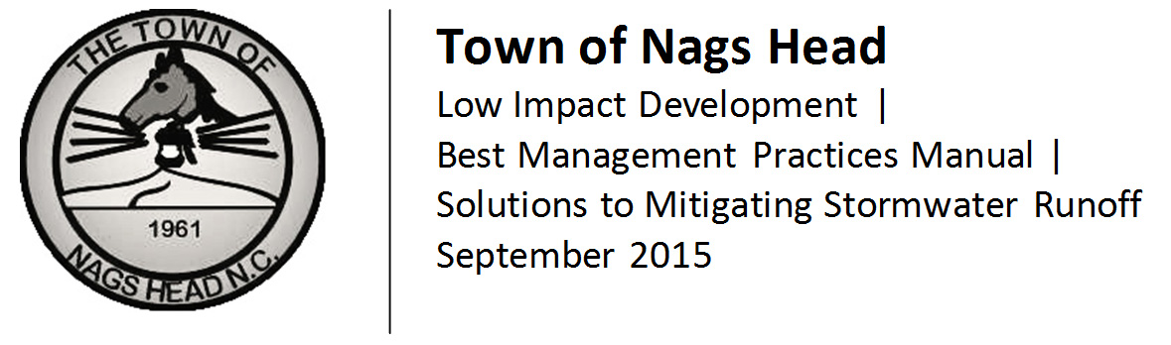

| Acknowledgements

In 2013, the Town of Nags Head began work with the N.C. Coastal Federation to develop a Low Impact Development manual as a reference document for local citizens and developers as part of Town efforts to improve stormwater management and as a technical resource for application of Town Stormwater regulations. This project is based on the LID manual for the coastal towns of Columbia, Cedar Point and Cape Carteret. The Town of Columbia worked in direct partnership with the N.C. Coastal Federation to complete an LID manual. The Town of Cedar Point worked in partnership with the Town of Cape Carteret, the N.C. Coastal Federation, engineering consultants Withers & Ravenel, N.C. Division of Water Quality and the LID Technical Review Team to complete the Cedar Point/Cape Carteret manual. We would like to thank these three communities and their partners for sharing their work and providing a model for us to follow. At the local level, the following people were involved in the development and review of the updated Stormwater Regulations which are referred to in this manual as well as for several exhibits provided.
Town Ordinance Update Committee
Marvin Demers
Richard Murphy
Pogie Worsley
Mark Cornwell
Bob Edwards
Kelly Wyatt, CZO
Dabni Shelton, CZO
Kim Allen
Andy Deel, P.E
David Ryan, P.E.
Elizabeth Teague, AICP, CTP

Town of Nags Head Board of Commissioners
2012-13
Mayor Bob Oakes
Mayor Pro-Tem Doug Remaley
Commissioner Susie Walters
Commissioner Renee Cahoon
Commissioner Anna Sadler
2013-14
Mayor Robert Edwards
Mayor Pro-Tem Susie Walters
Commissioner Renee Cahoon
Commissioner Marvin Demers
Commissioner John Ratzenberger

Town of Nags Head Planning Board
Marvin Demers
Richard Murphy
Pogie Worsley
Mark Cornwell
Bob Edwards
Barbara Gernat
Clyde Futrell
Toni Parker

Special thanks go to David Ryan, P.E., Andy Deel, P.E., and the North Carolina Coastal Federation staff for their contributions to this Manual. UNC Chapel Hill Outer Banks Field Site interns Mark Stripp and Katrina Phillips contributed the photographs.

| TABLE OF CONTENTS

- Background and Purpose

- Practices to Manage Stormwater Fact Sheets

- General Siting Considerations related to Separation Distances

- Using LID to Comply with Town Stormwater Management Requirements

Application Requirements

Residential BMP Selection Guide for Non-Engineered BMP'S
(For projects using fill amounts of greater than 1’ and less than 2')

Residential BMP Selection guide for Engineered BMP'S
(For fill amounts of greater than 2')
And Commercial/Multi-Family BMP Selection guide for Engineered BMP'S

- Reference Information

Glossary
Sources

Town of Nags Head
P.O. Box 99
Nags Head, NC 27959
North Carolina Coastal Federation
Northeast Office
128 Grenville Street
Manteo, NC 27954
- Background and Purpose

This manual is a guide for property owners who want to improve stormwater management on their site and for those who seek low cost practices to achieve compliance with the Town of Nags Head Stormwater Ordinance, Chapter 34 of the Town Code of Ordinances. Because we all play a role in protecting coastal waters, everyone can use the solutions described, not just those requiring permits. In so doing, everyone can help protect water quality and reduce the potential for localized flooding.

| What is stormwater runoff?

Stormwater run-off is precipitation shed off the ground or impervious surfaces. When rain reaches the ground, it infiltrates into the soil until the soil is saturated. This process naturally filters the water before it settles into aquifers or makes its way as groundwater to estuaries, the sound, or the ocean. The sandy soils of the Outer Banks generally absorb rainfall efficiently into the ground. However, some periods of rainfall may exceed the ground’s ability to collect and filter the water. Precipitation onto saturated ground can result in localized flooding.

Residential and commercial development can alter natural drainage patterns and increases impervious surfaces such as parking lots, driveways or rooftops which do not absorb water. Development activities which result in the removal of trees and other vegetation can effectively reduce natural passive stormwater measures such as evapotranspiration, (plant uptake). This can result in less precipitation being absorbed into the ground or used by plants and increasing the potential for runoff being conveyed off-site.

Rainfall runoff can collect pollutants which are discharged to the bodies of water that we depend on for food, income and recreation. As rain hits a surface, the runoff collects chemicals, oil, antifreeze and refuse from parking lots, or fertilizers, pesticides, and sediment from lawns and gardens. Run-off can also pick up loose soil or scour the ground, producing erosion. Sediment and silt carried by stormwater can impede drainage flow resulting in reduced system effectiveness.
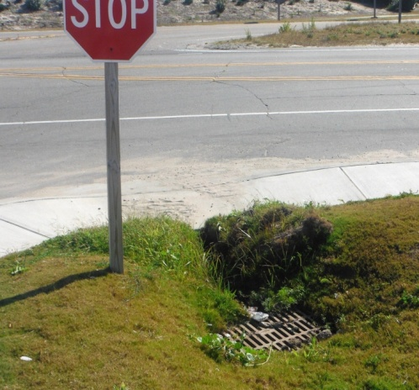

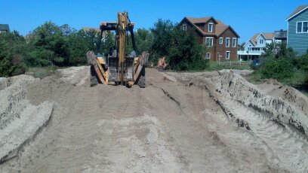
| What Is Low Impact Development?

This manual focuses on Low Impact Development or “LID” approaches to managing stormwater. The goal of LID is to mimic the natural hydrological function of the landscape on any given site.

LID uses techniques to capture and store stormwater as close to the source as possible to promote infiltration and treatment, thereby reducing runoff and the amount of pollution that runoff can convey. LID practices include site planning that provides small, decentralized management practices and approaches that are versatile and site specific.

Unlike conventional strategies that treat stormwater as a secondary component of design, LID incorporates the natural slope, soils and hydrology as a framework for development design.

For new development, an LID approach identifies natural features and strategically places buildings, driveways and parking areas advantageously to allow for a stormwater management system that works with existing natural features and drainages.

In redevelopment, LID includes forming an inventory of built and un-built areas and incorporating strategies and technologies to handle existing conditions and maximize infiltration in existing open space. The cumulative impact of retrofitting techniques can have a significant impact.

The desired result is a functional landscape that generates less runoff, less pollution, less erosion and less overall damage to coastal waters. The attention to natural hydrology and integrated use of open space and vegetation, also results in attractive, multi-functional landscapes.
Key Principles in Low Impact Development:
- Focus on Prevention.
- Protect wetlands, floodplains and coastal habitats.
- Maintain slopes and flow paths.
- Minimize grading and tree clearing.

- Work with the Landscape.
  - Identify environmentally sensitive areas.
  - Outline a plan to protect those areas.
  - Use hydrologic features of the site.

- Keep it Simple.
  - Use low-cost approaches to decentralize run-off
  - Micromanage stormwater close to where it falls
  - Direct run-off from impervious surfaces to landscaped areas and other small scaled techniques for infiltration.

- Practice multi-tasking.
- Use landscaping for a variety of purposes. Landscapes can capture and treat pollutants and provide curb appeal.
- Distribute management practices on a site so that they work together to reduce run-off and run-off impacts.

- Maintain and Sustain
- Maintain LID features so that they remain effective and provide long-term success.

| What is a Best Management Practice or BMP?

Best Management Practices or “BMPs,” are inter-changeable terms which describe the techniques implemented to treat or limit pollutants and other damaging effects of stormwater runoff. In North Carolina, these terms are used to describe the techniques implemented in order to meet legislative and North Carolina Administrative Code requirements. The North Carolina Stormwater Best Management Practices Manual or “NCDENR BMP Manual” is the stormwater design manual approved by the North Carolina Division of Energy, Mineral and Land Resources. This document is designed to be a local version of a BMP Manual, providing guidance for practices which can be utilized effectively in the Nags Head environment and to meet the Town’s Stormwater Management requirements.

The term best management practice or BMP encompasses two major categories of BMPs: non-structural and structural. Non-structural BMPs are typically passive or programmatic and tend to focus on source control and pollution prevention; reducing pollution in runoff by reducing the opportunity for the stormwater runoff to become concentrated and exposed to pollutants. Structural BMPs refer to physical structures designed to remove pollutants from stormwater runoff, reduce downstream erosion, provide flood control, and promote groundwater recharge.

| How To Use This Manual:

This Manual provides information in three major areas.

- Chapters 2 and 3 of this Manual offer a variety of LID “Best Management Practices” (also called “BMPs”) and considerations to keep in mind when choosing which types of practices for different sites. With this guidance, anyone can incorporate one or more practices into their site for improved stormwater management, both in new development and in re-use of existing developed sites. Practices are described in Chapter 2 with Fact Sheets which are intended for easy reference and to be used individually or together to create a stormwater management strategy for a given project. Each Fact Sheet contains a brief overview of the LID technique, its benefits, information on installation and maintenance, and reference information. Chapter 3 provides additional information on siting the BMP relative to maintaining required distances from septic systems and wetlands.

- Chapter 4 of the Manual is an overview of the Town’s application requirements for those who have to comply with the Town’s Stormwater Management Ordinance, Chapter 34 of the Town’s Code of Ordinances. These requirements apply to commercial and multi-family projects and for individual sites of residential development that use fill. While LID techniques are applicable to commercial projects, this Manual will be particularly helpful for individual residential lot development and lays out a step by step approach for developing a stormwater management plan that will comply. Residential development that does not use fill in excess of 12” in depth, lot disturbance limited to site investigations (for the purpose of surveying or determining septic suitability), and land disturbance and fill used in the repair and/or replacement of existing septic systems, are exempt from the Town’s stormwater management requirements, but can still benefit from applying LID techniques.

- Chapter 5 of the Manual provides reference material regarding the Nags Head environment, soil types, and other useful information. This section also includes sources for additional information and application forms.

Questions regarding this Manual or the Town’s development requirements should be directed to the Town of Nags Head Planning and Development Department, located at 5401 South Croatan Highway in Nags Head, NC, 27959, (252) 441-7016.

In addition to this Manual, the following are also useful references:

The North Carolina Manual for Stormwater Best Management Practices, available at the NC Division of Water Resources (NCDWR): http://portal.ncdenr.org/web/lr/bmp-manual

The Low Impact Development Guidebook by NC State University, available at: http://www.ces.ncsu.edu/depts/agecon/WECO/lidguidebook/

Stormwater Best Management Practices by the US EPA, available at: http://water.epa.gov/polwaste/npdes/swbmp/

2. Best Management Practices
| Site Fingerprinting

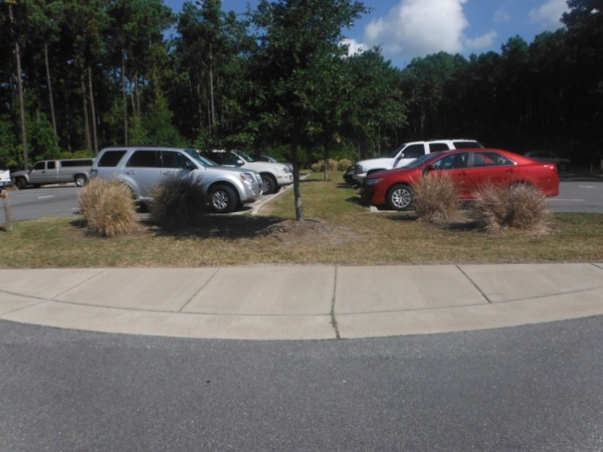

What Is Site Fingerprinting?
-Site Fingerprinting is a practice that uses site design as a stormwater management tool by reducing land disturbance, preserving soil structure, and utilizing suitable natural areas (rather than expensive structural practices for runoff management).
-Rather than grading land to fit a desired development type, the type of development is dictated by the existing conditions of the site, resulting in a developed site which uses the land to maintain and protect the natural balance of the surrounding ecosystem.

Did You Know?
-Site Fingerprinting can be done during the planning process for no additional cost and can often lead to reduced infrastructure costs.
-By fitting the development to the land, it is often easier to preserve existing vegetation, giving a more established look to new developments.
-A little preservation goes a long way toward effective stormwater management.

Benefits
- Reduced stormwater runoff volumes discharged into our waterways
- Maintained natural drainage patterns
- Reduced infrastructure costs
- Healthier green space

Helpful Hints
When trying to preserve the health of the local watershed, the best place to start is to enhance and preserve the natural stormwater treatment areas. These include marshes, wetlands, and coastal forests, which have great potential to control and treat stormwater runoff.

Where to Start
- Start by identifying the natural characteristics of a site. Conduct “natural resources inventory” of what’s already there.
- Wetlands
- Shoreline
- Floodplain
- Forests
- Flow patterns
- Depressions and natural low areas

- Determine site potential for LID stormwater treatment.
- Locate development on the least sensitive natural areas
- Protect the preservation areas during construction
- Use density where appropriate
- Minimize soil compaction during construction
- Use disconnected impervious areas to minimize runoff volumes
- Use the natural drainage patterns

References and Resources for Site Fingerprinting
Low Impact Development Center: www.lowimpactdevelopment.org
Green Growth Guidelines, Chapters 1-6, Site Fingerprinting Utilizing GIS/GPS Technology: http://coastalgadnr.org/cm/green/guide
Urban Land Institute: http://www.uli.org/wp-content/uploads/2012/07/EnvironmentandDev.ashx.pdf
American Institute of Certified Planners (AICP): www.planning.org - search stormwater
American Society of Landscape Architects (ASLA): www.asla.org - search LID
Ladybird Johnson Wildflower Center: http://www.wildflower.org/- search LID

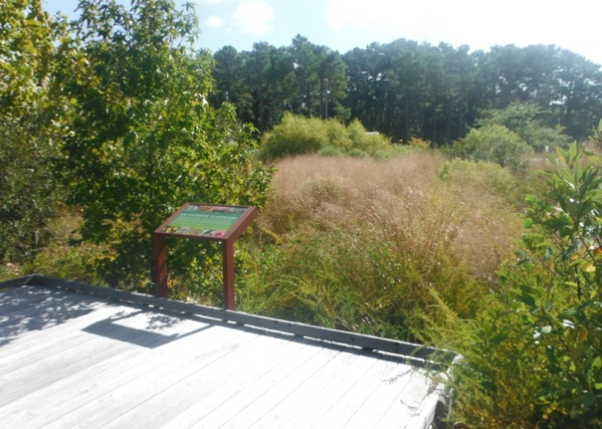

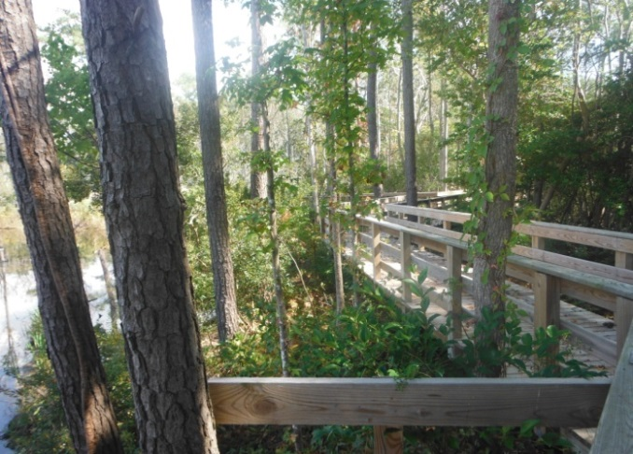

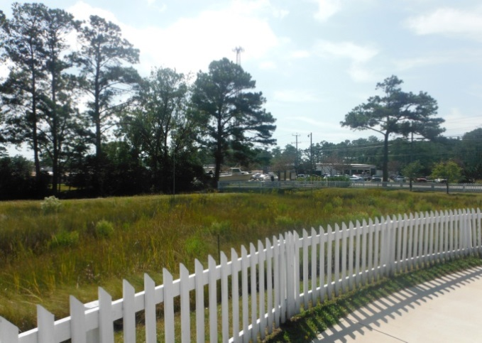

| Disconnected Impervious Surfaces

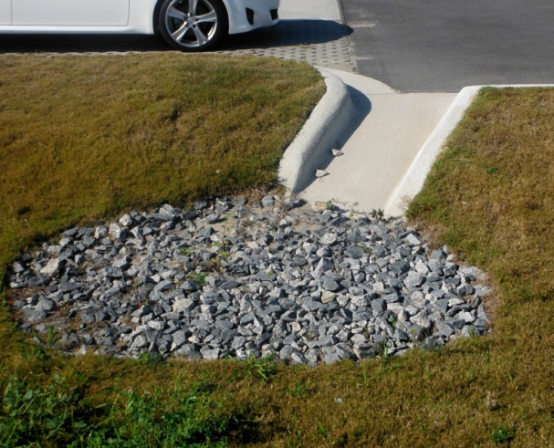

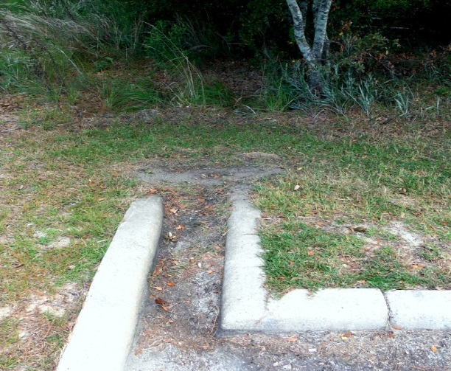

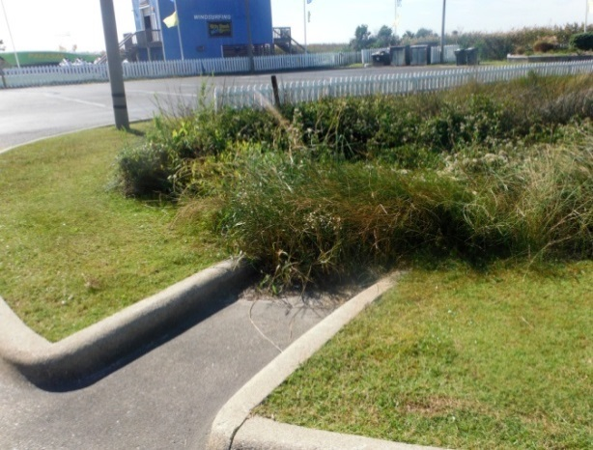

What is a Disconnected Impervious Surface?
-Roof tops, parking lots, and other impervious surfaces often drain directly to pipe systems or ditches, increasing runoff and preventing rainwater from soaking into the ground.
-Disconnected impervious areas are those which divert or direct stormwater to naturally vegetated areas.
-This reduces pollution by slowing down the runoff, increasing infiltration, and filtering flow through vegetation.

Did You Know?
-During small storms, disconnected impervious areas can reduce runoff volume by 30% to 100%.
-This technique also reduces the need for irrigation, and lowers infrastructure costs.
-This approach spreads multiple practices throughout a site, as opposed to the costs and maintenance problems associated with one large retention pond.

Benefits
- Reduces stormwater runoff volumes discharged into our waterways

- Reduces infrastructure costs

- Reduces dependence on irrigation

- Provides healthier green space

- Can provide a distributed regime which diffuses runoff and pollutant concentration.

Helpful Hints
-For the best effect, tie multiple practices together, using disconnected impervious areas as part of a larger stormwater management strategy.

Where to Start
- As a retrofit, see if it’s possible to add curb cuts in the edge of existing parking lots to allow runoff to flow into vegetated areas.
- On new or re-development sites, try to slope the parking lots, roofs, and sidewalks into landscaped areas, open spaces, or woods.
- Use rip-rap or concrete or other material to create edging to prevent erosion.
- Make sure water is directed away from buildings.
- Disconnect the building downspouts (See Simple Solutions Sheets) and develop landscaped areas along the drip line to diffuse roof runoff.

References and Resources
See the “Simple Solutions: Downspout Disconnection” sheet for more help. Contact your local nursery or Town staff for more assistance.
NC Cooperative Extension: www.ces.ncsu.edu
search impact solutions
Low Impact Development Center: www.lowimpactdevelopment.org
NC Coastal Federation: www.nccoast.org
search for disconnected impervious surfaces
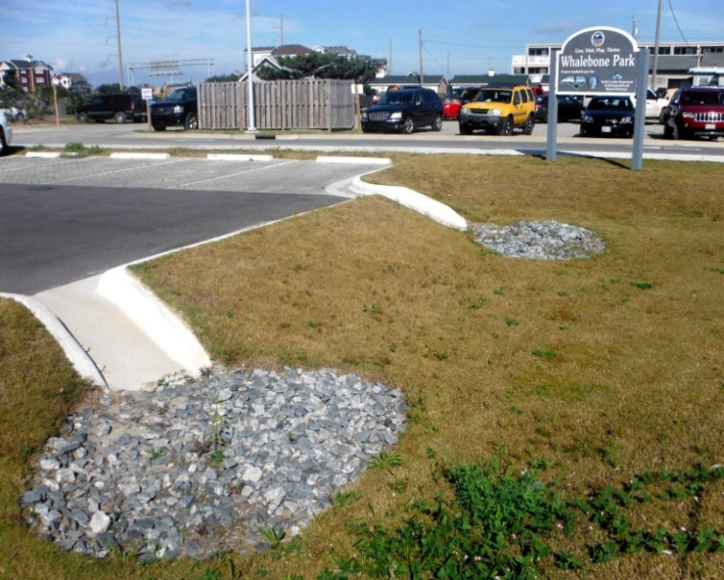

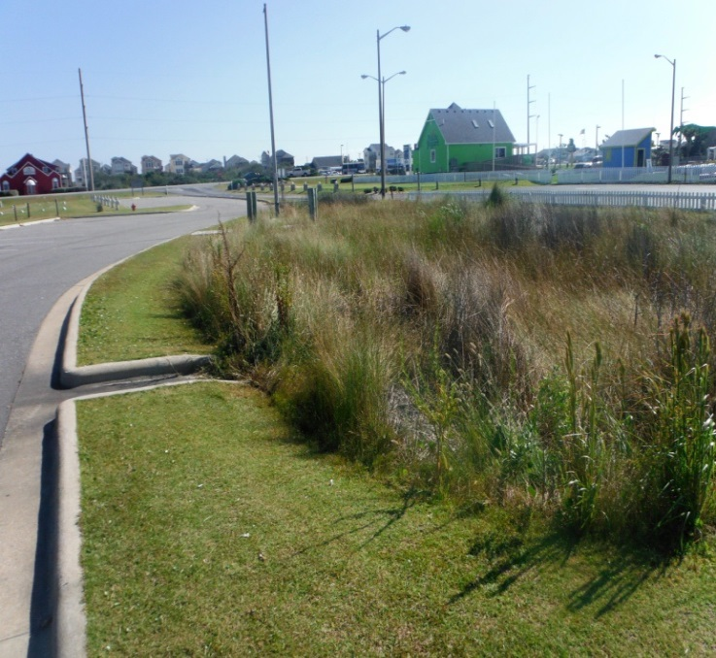

| Planter Boxes
What is a Planter Box?
-Planter boxes use soil with high flow rates of filtration. Soil media can control and treat runoff. Runoff flows through the sandy soil mix, which traps solids and pollutants.
-Planter boxes use vegetation to help absorb the water trapped by the soil. The plants also create a mini ecosystem within the soil, fostering healthy microbes which aid in breaking down oil and grease.

Did You Know?
-Planter Boxes can be integrated into the existing storm drainage system with minimal disturbance, making them an excellent retrofit.
-Planter boxes provide treatment at the source in a small footprint.

Benefits
- More trees, flowers, and shrubs reduce runoff volume and pollution.

- Small footprint allows boxes to be easily integrated into sites and are great retrofits.

- Planter boxes can be used to visually soften or create buffers in hardscape areas such as along parking lots or walkways.

Helpful Hints
-Use the planter box upstream of an underground BMP such as a cistern so that the water entering the device is cleaner.
-Holes in the bottom of the box increase filtration if underlying soil is suitable.

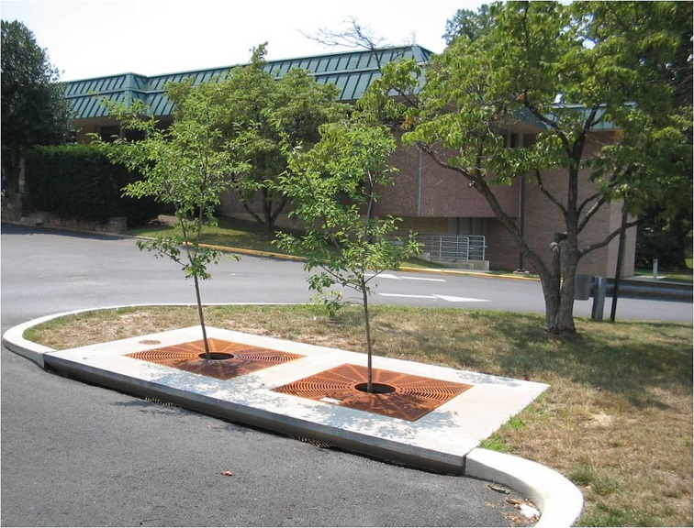

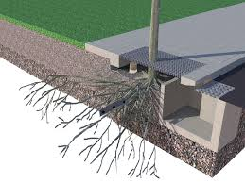

Where to Start
- Location
-Site the planter box in the curb line, immediately upstream of a catch basin or inlet.
-Typical boxes are 3’ deep – make sure there is a suitable outfall to drain the box between storms.
-The box should be oriented so flow comes across inlet throat, not directly at inlet opening.
-Use plants that are native to coastal NC.

- Sizing
-The soil media should be at least 3’ deep.
-The minimum soil infiltration rate should
be 10” per hour or greater.

 | Max Impervious Area
Planter Box Size
 | (acres)
4' x 6' | 0.14
4' x 8' | 0.19
4' x 12' | 0.28
6' x 6' | 0.21
6' x 8' | 0.28
6' x 10' | 0.35
6' x 12' | 0.42
7' x 13' | 0.54

- Installation
-Contractor assistance will be required.
-Many manufactured systems are available, contact a manufacturer for specific installation guidelines.

References and Resources
Low Impact Development Center: www.lowimpactdevelopment.org; search planter box

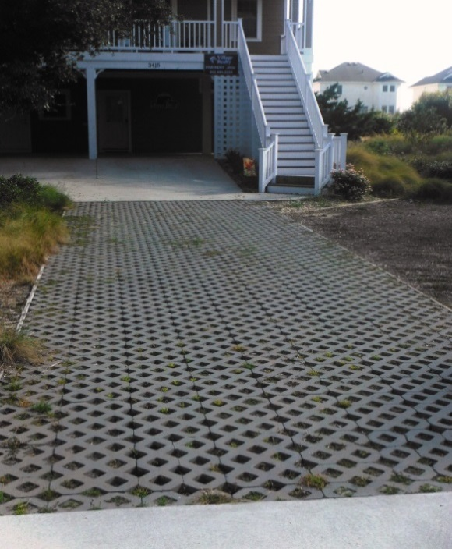

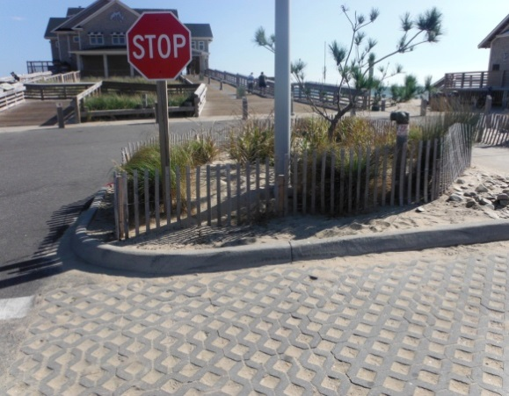

| Permeable Paving
What is Permeable Paving?
-Permeable pavement is any paving material that allows rainwater to percolate through the pavement and infiltrate the soil.
-Permeable paving comes in various forms: pervious concrete, pervious asphalt, and concrete pavers are some of the most popular materials.
-Permeable paving systems require a washed stone base, which aids in adding runoff storage volume as well as structural support.
-Permeable paving must be installed correctly and to manufacturer’s specifications in order to be effective and requires Town Engineer approval.

Did You Know?
-The concrete industry has data on the long term performance and cost-benefit of using pervious pavement systems.
-Permeable pavement has been used successfully in many locations in North Carolina and Nags Head.

Benefits
- Increased infiltration and reduced runoff.

- Opportunity for artistic design if pavers are used.

- Beneficial way to reduce runoff without losing parking,

- Receives a 33% credit in lot coverage calculations by the Town of Nags Head.

- Works well in retrofits as long as sub-base material and soils are appropriate.

Helpful Hints
Permeable pavements can be used in conjunction with underground detention or rainwater harvesting systems to gain additional stormwater benefits.

-There are thousands of paver and material options which provide many aesthetic choices.
-Contact your local contractor for more information.

Where to Start

- Location
-Pervious pavement systems should be sited on generally flat areas.
-Edge restraints are recommended.
-Obtain a soil test to determine infiltration characteristics before installing pavements because an under drain might be needed.
-Only install permeable systems where the seasonal high water depth is adequate to permit the system to drain completely.

- Sizing
-Consider using a thicker washed stone base to increase storage capacity and further reduce runoff volumes.

- Care
-Systems should be checked regularly for proper drainage.
-Important to keep surface clean of debris which can clog porous material. If infiltration rate decreases, clean the surface layer.
-If system still loses infiltration capabilities, contact an engineer or qualified contractor.
-Potholes, cracks, or damaged pavers should be repaired or replaced.

References and Resources

Carolina Ready-Mix Concrete Association: www.crmca.com

Pervious Pavement: www.perviouspavement.org/

Concrete Network: www.concretenetwork.com/pervious/

Low Impact Development Center: www.lowimpactdevelopment.org

NC DWQ BMP Manual, Permeable Pavement: http://portal.ncdenr.org/web/lr/bmp-manual

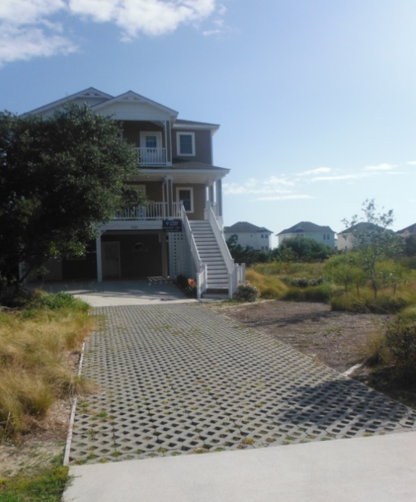

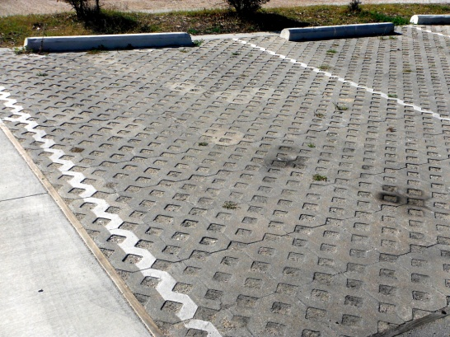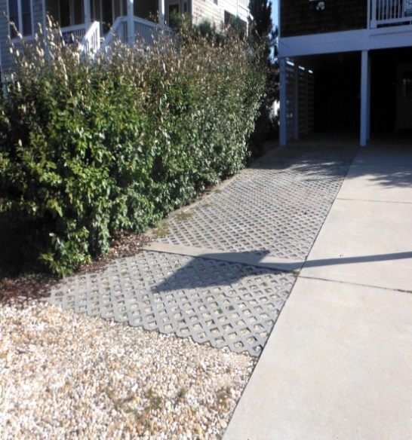

| Re-routing of Downspouts to Direct Roof Run-off.

Why Re-route Downspouts?
-Downspouts directed to driveways, sidewalks or parking lots increase the amount of polluted runoff by an average of 50 percent or more.
-Instead of contributing to stormwater pollution, you can put rain water to use by redirecting it to vegetated areas or yards.
-Downspouts used in connection with rain barrels or cisterns can also collect rain water for use during dry periods.
-Redirecting roof runoff is cost effective, easy to do and virtually maintenance free.

Did You Know?
During the summer months, nearly 40 percent of household water is used for lawn and garden maintenance.

Benefits
- Reduced runoff volume
- Reduced pollutants
- Reduced flooding
- Directs stormwater into areas that need water, saving irrigation and watering.

Helpful Hints

Re-route your downspout with these few simple techniques:
- Direct downspouts to areas that can infiltrate into the ground. Downspouts can direct flow into landscaped areas and rain gardens.
- Turn downspouts away from sidewalks and driveways into yards and other vegetated areas.
- Use pop-up emitters to direct runoff to landscape areas.
- Link downspouts to rain barrels or cisterns to collect water for future use.
- Use extension gutters or splash blocks to help diffuse the flow of water.
- Re-route all stormwater at least five feet from your foundation.
- Avoid routing downspouts to neighboring property or directly over a septic system or drain field.

References and Resources
Mid-America Regional Council: www.marc.org/environment/water
North Carolina Coastal Federation: www.nccoast.org
City of Portland Stormwater Solutions Handbook: www.portlandonline.com
DC River Smart Homes: www.ddoe.dc.gov; search downspout disconnection

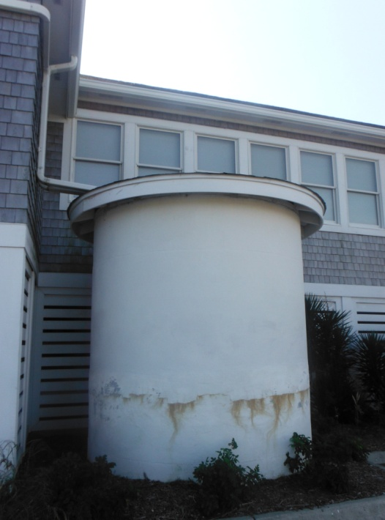

| Cisterns
What is a Cistern?
Cisterns are large water harvesting systems which collect rain water and store it for future use. In contrast to a rain barrel, which stores only a small volume of water, cisterns are sized to capture larger volumes of water and can be installed above or below ground. This water can then be reused for irrigation, industrial processes, and/or commercial reuse.

Did You Know?
-For every inch of rain that falls on a 1,200 square foot area, approximately 750 gallons of stormwater runoff is produced.
-For high water consumption users, cisterns can be a financially profitable investment, paying for themselves by reducing or even eliminating water bills for non-potable uses.

Benefits
- Lower water bills
- Reduced runoff and stormwater pollution
- Available water for use during drought conditions

Helpful Hints
-Check with Town Building Inspector before construction.
-Cisterns are often visible “green” elements of a property and many aesthetic options are available.
-Low cost filters are available to prevent clogging and reduce maintenance needs.
-Computerized water management systems can optimize performance.
-A cistern system that minimizes sunlight penetration can help prevent bacteria and mosquito growth.
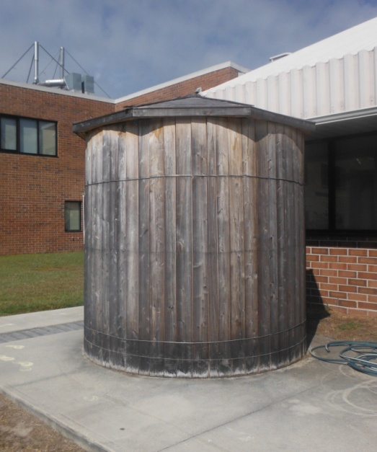

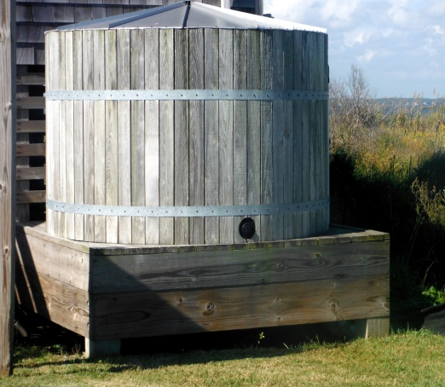

How to Size and Install Your Cistern
- Location
-Look for ways to connect multiple downspouts into a system.
-For especially large systems, water can be stored underground in vaults or other engineered systems.

- Equipment
-Heavy construction equipment is often required, but most commercial contractors have the equipment which would be needed.
-There are a number of specialized rainwater harvesting contractors who offer comprehensive design and installation services.

- Considerations
-Cisterns can be used on existing development or new construction.
-A full cistern is heavy and may require additional support, such as a concrete or gravel pad.
-If rainwater is to be used inside a building for non-potable uses, dual plumbing systems will be required.

References and Resources

NC Cooperative Extension: www.ces.ncsu.edu; search cisterns

NC Community Conservation Assistance Program: http://www.ncagr.gov/SWC/costshareprograms/CCAP/index.html

NC State University: www.bae.ncsu.edu/topic/waterharvesting

NC DWQ BMP Manual, Rooftop Management: http://portal.ncdenr.org/web/lr/bmp-manual

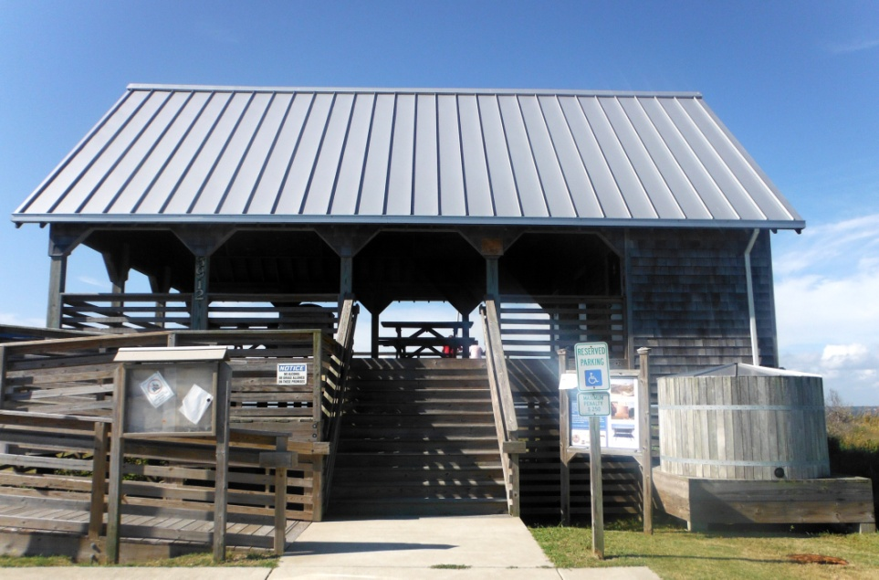

| Rain Barrels
What is a Rain Barrel?
A rain barrel is a container that collects and stores rainwater from your roof that would otherwise be lost to runoff. Rain barrels come in all shapes and sizes. They typically include the drum, a vinyl hose, PVC couplings and screen to keep debris and insects out. A rain barrel can sit conveniently under any residential gutter downspout.

Did you know?
-One quarter inch (¼”) of rain produces enough runoff to fill a typical rain barrel hooked up to one downspout.
-If you and your neighbors all added just one rain barrel per residence, it would have a significant impact on flooding and pollution in your community.
-One 55 gallon rain barrel holds a full week’s worth of water for a 10’x10’ garden.
-Rain barrels come in a variety of sizes, colors and designs and are available for purchase locally and on-line.

Benefits
- Lower water bills

- Reduced runoff and stormwater pollution
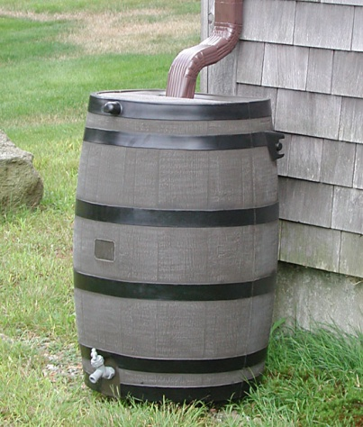
- Available water for watering plants during drought

- The natural nutrients of rainwater needed -for healthy plants
Helpful hints
-Always keep the lid to your barrel tightly secured to avoid any accidents involving children or animals.
-Do not consume water collected in barrel!

How to Size and Install Your Rain Barrel
-Most rain barrels are easy to install; however, actual installation methods vary depending on the type of rain barrel. Installation typically involves disconnecting your downspout, cutting off a portion of the downspout and redirecting it into the top of the barrel.

-Most rain barrels have an overflow pipe that redirects the rainwater back into the downspout or onto your lawn or other surface in the event the barrel is full.

-Some barrels come with safety features, spigots, mosquito proofing, and even water filters.

-Some barrels come with connection attachments so that multiple barrels can work together.

Care

-Use water between rains, or empty prior to storms.

-Annually empty and wash out barrel.

-Clean your gutters regularly to prevent debris.

-If you see algae, add one cap of chlorine bleach to a full barrel of water; this small amount won’t hurt plants.

References and Resources

NC Cooperative Extension: www.ces.ncsu.edu ; search rainwater

NC State University: www.bae.ncsu.edu/topic/ ; click water harvesting

NC Coastal Federation: www.nccoast.org ; click low impact development

| Rain Gardens

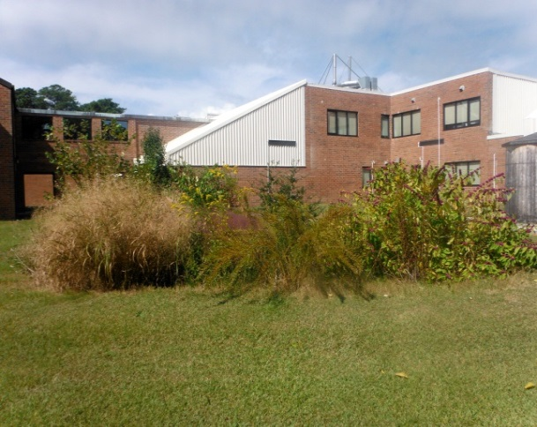

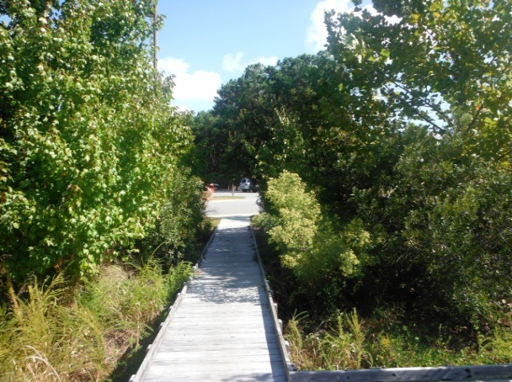

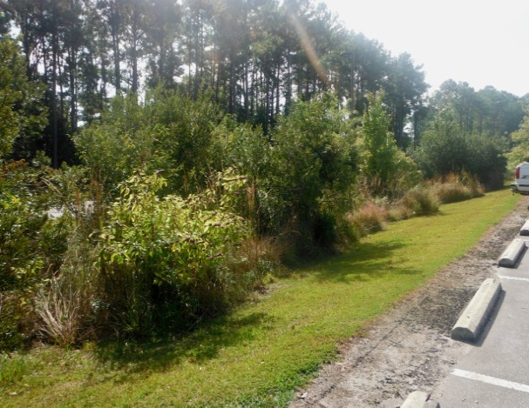

What is a Rain Garden?
Rain Gardens are small, shallow, vegetated areas where rainwater collects during storms. Rain gardens are typically 4-8 inches lower than the surrounding lawn and act as a bowl that collects runoff. The plants and soil soak up the rain water before it becomes polluted runoff.

Did You Know?
-Rain gardens can reduce runoff by 90% or more.
-Rain gardens enhance yards and landscapes and can host a variety of plants.

Benefits
- Reduced stormwater runoff
- Reduced pollutants
- Reduced flooding
- Natural stormwater treatment
- Enhanced curb appeal of your yard

Helpful Hints
-Observe water flow patterns during rains to determine potential areas for rain gardens.
-Use native plants for lower maintenance.
-Rain gardens may not be suitable in areas with standing water. (See Backyard Wetland fact sheet).
-Make sure water from rooftops or driveways is directed into the garden.

Build and Plant

- Location
-Select an area to capture and absorb runoff based on how water flows across your land.
-Site the garden at least 10’ from your house, and 25’ from wells or septic fields.
-Make sure the soil will drain.
-Plant flowers, shrubs, grasses or even turf.

- Equipment
-A small rain garden can be built by hand in a weekend. Contact Town staff or a local contractor for additional assistance if needed.

- Planting
-Heavy double or triple shredded hardwood mulch works best because it won’t float away. It also helps retain moisture for the plants.
-Choose native vegetation when possible.

- Care
-Periodically water garden until established.
-Mulch annually.

References and Resources
See the “Native Landscaping and Tree Planting” fact sheet for more help, or contact your local nursery or Dare County Cooperative Extension for more assistance.
NC State University Rain Garden Guide: www.bae.ncsu.edu; search rain gardens

NC Cooperative Extension: http://www.darenc.com/soilwater/raingrdn.asp

NC Coastal Federation: www.nccoast.org; search low impact development

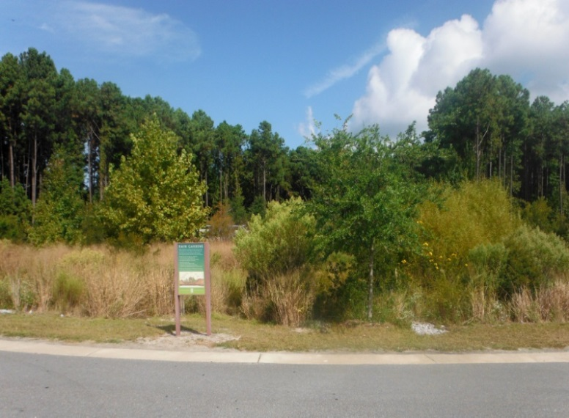

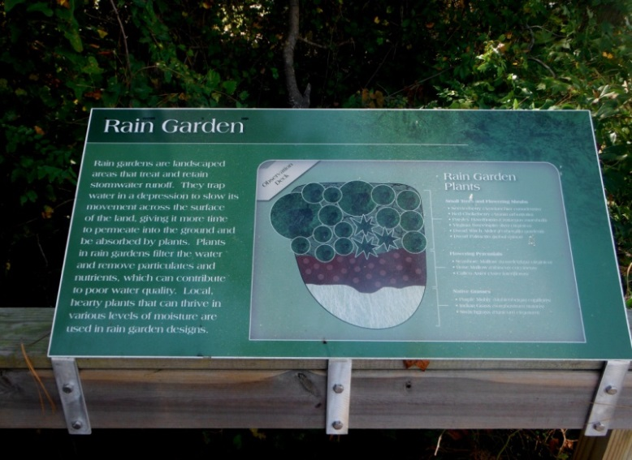

| Backyard Wetlands
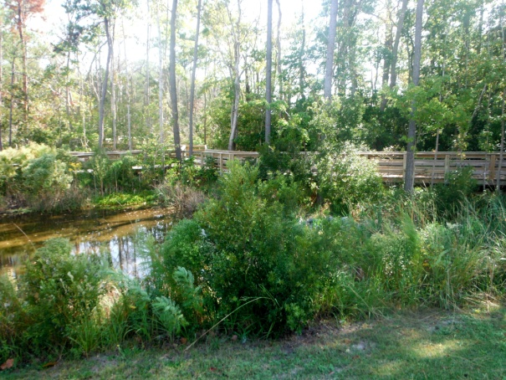

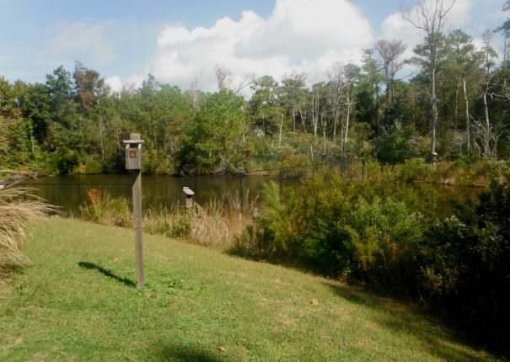

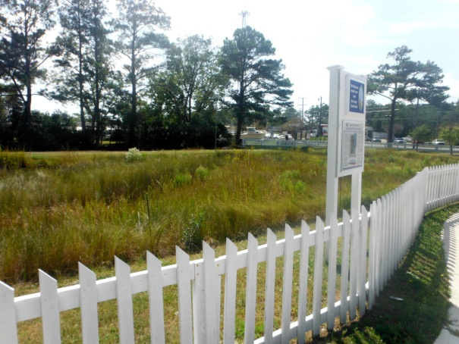

What is a backyard wetland?
Backyard wetlands are depressed wet areas that are planted with native wetland plants. They are well suited for areas that are usually wet for several days following a rain event. Backyard wetlands are designed to capture and treat stormwater similar to a rain garden but in locations with high-water tables and soggy soils.

Did you know?
-Man-made backyard wetland gardens can provide many of the same benefits of natural wetlands.
-A wetland will temporarily store, filter, and clean runoff water from your roof and lawn.
-It will provide habitat for butterflies and bees, salamanders, toads, frogs, and birds.

Benefits
- Capture, reduce and filter runoff

- Enhanced landscaping

- Bird and butterfly habitat

Helpful Hints
-Locate the backyard wetland where it is not likely to attract unattended children.
-Check local safety ordinances and building ordinances for restrictions and permit requirements.
-Check soil maps to locate wetlands appropriately.

Build and Construct
-Choose areas of your lawn that include naturally occurring wet spots for your wetland.
-Locate wetland at least 10 feet from any foundation.
-Setback at least 25’ from septic fields and well heads.
-Ponding depth of wetland should be no more than 9”.
-Refer to Common Wetland Plants of North Carolina to choose native plants to use in your backyard wetland.

References and Resources
Natural Resources Conservation Service: http://www.nrcs.usda.gov/wps/portal/nrcs/site/national/home/
NCSU Urban Waterways – Designing Stormwater Wetlands for Small Watersheds:
http://www.bae.ncsu.edu/stormwater/PublicationFiles/SWwetlands2000.pdf
Common Wetland Plants of North Carolina, produced by the N.C. Department of Environment and Natural Resources, Division of Water Quality:
http://portal.ncdenr.org/c/document_library/get_file?uuid=d0f7bb32-5585-4acf-a399-8d484488d234&groupId=38364
Division of Soil and Water Conservation Community Conservation Assistance Program:
http://www.ncagr.gov/SWC/costshareprograms/CCAP/index.html

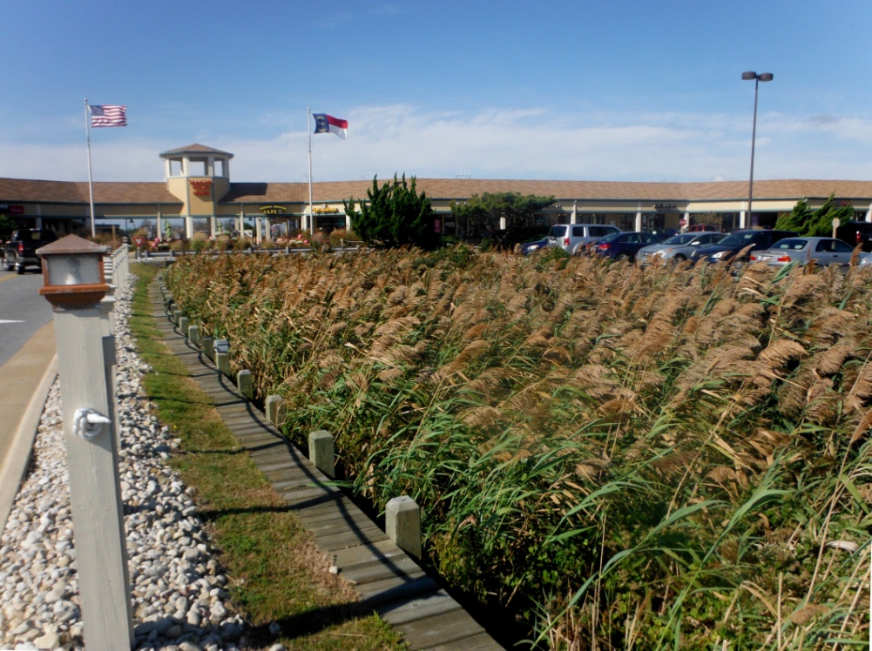

| French Drains
What is a French Drain?
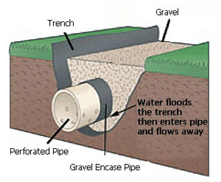
A French drain is a trench covered in washed stone or other approved media that diverts surface and groundwater away from a specific area. French drains are a commonly used drainage system, primarily applied as a preventative measure against surface and ground water penetrating and/or damaging foundations. French drains are also used behind retaining walls to relieve ground water pressure or strategically placed in flat areas to drain standing water from the yard. Alternatively, the French drain technique may be used to capture, collect, and convey runoff to a secondary stormwater BMP device when site constraints may not permit adequate width for a vegetative swale.
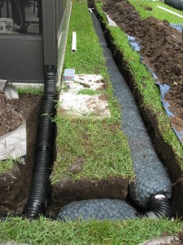
Benefits
- Intercepts stormwater runoff
- Enhances groundwater recharge
- Can provide temporary storage
- Can be used for conveyance
- Can be used in limited space
- Provides for an underground solution

Build and Construct
-Choose an appropriate location based upon whether the application will capture runoff by way of sheet flow or conveyance, (from a gutter system downspout) .
-Can be located adjacent to a building foundation. Locate at least 5 feet horizontally from any septic system.

-Locate at least 1’ vertically above water table.
-Excavate trench, install geotextile fabric by lining inside ditch bottom and walls, and install perforated pipe, slope at 1 in. per 10’ of length.
- Backfill trench with clean washed gravel.

| Native Landscaping and Tree Planting

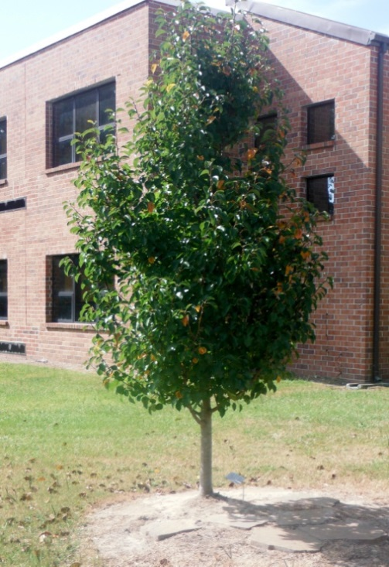

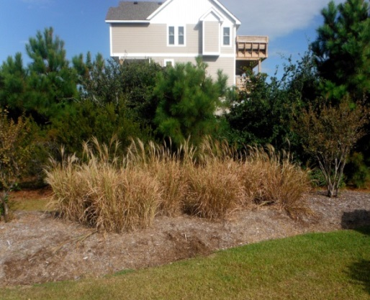

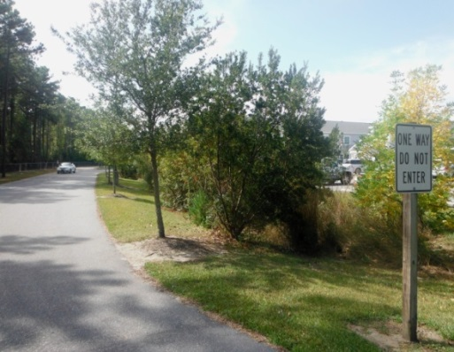

What is Native Landscaping and Tree Planting?

Native landscaping uses plants that occur naturally in our coastal region, and were not introduced by human action. Native plants have adapted to the geography, hydrology, and climate of the region.
Planting trees can help reduce stormwater by intercepting it and allowing it to evaporate, as well as dissipating the energy of runoff. They also provide shade, which keeps surface temperatures lower and facilitate stormwater infiltration.

Did you know?

-Native trees/plants are hardy and suited to our soils and climate and are part of our coastal heritage.
-Require little care once established as compared to non-natives.
-Absorb and slow the flow of stormwater runoff.
-Prevent erosion and increase soil permeability.

Benefits
- Native plants provide beautiful, hardy, drought resistant and low maintenance landscapes while benefitting the environment.
- Native plants, once established, save time and money by eliminating or significantly reducing the need for fertilizers, pesticides, irrigation and lawn maintenance equipment.
- It is estimated that one hundred large mature trees intercept 1.2 million gallons of rainfall per year, and for every 5 percent tree cover added to a community, stormwater runoff is estimated to be reduced by approximately 2 percent.
- Properties with trees are estimated to be valued 5 to 15 percent higher than comparable properties without trees.

Helpful Hints
-Direct runoff to native landscaping or rain garden to capture stormwater and create beautiful habitats.
-Design yard features that include depressions with native plants.

Build and Plant
Use the landscape to help keep rain water on site.
Plant trees that maximize interception of rain.
Plant native trees with higher growth rates.

References and Resources
www.ncsu.edu/goingnative/howto/index.html
NC Coastal Federation: www.nccoast.org; search native plants
Water Forestry Guide: www.forestsforwatersheds.org
Local Nurseries and Landscape Professionals
http://www.naturesharmonynursery.com/

| 3. Siting Considerations Related to Separation Distances

As part of “site fingerprinting” and the selection of management practices, a property owner or designer must assess the physical and environmental features at the site to determine the optimal location for managing stormwater. Nags Head is dependent on natural wastewater treatment systems and is surrounded by coastal surface waters and marsh which may be regulated under local or federal law.

Required separation distance from wastewater systems:
Single-Family Residential or Duplex Development on individual lots with conventional septic systems:
- Grassed Infiltration Swales (1.9’ depth or less): 5 ft.*
- Grassed Infiltration Swales (2’ depth or more): 10 ft.*
- Infiltration Basins: 10 ft.*
- Raingardens (Dry/ no liner): 5 ft.*
Raingardens (Dry/ with liner): 10 ft.*
Raingardens (Wet): 50 ft.*
- Grassed Filter Strip: 5 ft.*
- Permanent Storm Retention Pond: 50 ft.**
*Horizontal distances as prescribed by the Dare County Department of Environmental Health
**As per 15A NCAC 18A Laws & Rules Regulating Sewage Treatment & Disposal Systems
Single-Family Residential or Duplex Development on individual lots with alternative septic systems
- As per 15A NCAC 18A Laws & Rules Regulating Sewage Treatment & Disposal Systems.

General Standards for Commercial or Residential Subdivisions
• As per 15A NCAC 18A.1900 Laws & Rules Regulating Sewage Treatment & Disposal Systems.
- As per 15A NCAC 2T.0100 Waste Not Discharged to Surface Waters.

Required separation distance from wetlands:
- A 25’ horizontal setback to “404” Jurisdictional wetlands is recommended.

Required separation distance of fill slopes from property boundaries:
- Fill slopes must be set back at least 5’ from the property boundaries.
4. Using LID to Comply with Town Requirements
When is a stormwater plan required by the Town of Nags Head?
The requirements to retain and treat stormwater on site are described in Chapter 34 of the Town’s Code of Ordinances.
- A stormwater plan is not required for residential development that does not use greater than 1’ of fill, lot disturbance limited to site investigations (for the purpose of surveying or determining septic suitability), and land disturbance and fill used in the repair and/or replacement of existing septic systems.

- A stormwater plan is required as part of an application for commercial and multi-family development and redevelopment and for residential development that uses fill. If your project is a single-family or duplex residential lot using fill, note that there are two tiers of stormwater planning:
- Residential NON-ENGINEERED Plans for fill amounts of 1’ to 2’ in depth.
- Residential ENGINEERED Plans for fill amounts of greater than 2'.

Who can develop a stormwater plan?

For a stormwater plan for a commercial, mixed-use or multi-lot development such as a subdivision, a designer shall be a qualified and registered design professional knowledgeable within the field of work for the performance of the design, construction, and operation and maintenance of what is being proposed. This could include someone qualified in engineering, landscape architecture, architecture or environmental design. Stormwater plans that include engineering, or those plans that utilized a height of fill greater than 2 feet from the existing or natural grade, must be sealed by a Practicing Engineer and will be reviewed by the Town Engineer.
For a stormwater plan for a single-family residential application where proposed fill amounts are greater than 1’ do not exceed 2’ in height from the pre-development surface grades, then the design may be submitted by anyone, including those who are not registered design professionals or engineers, as long as the plan follows the guidelines for management practices provided in this manual. The goal is to allow smaller scale projects to be developed with minimal up-front costs through the implementation of LID approaches outlined in this Manual. For example, the design of swales must follow the specifications laid out in Table A. The design of rain gardens must follow the specifications of Table B. Stormwater Plans developed under this approached will be reviewed by Town staff certified in LID.
Stormwater plans submitted are not required restricted to the management methods described within this manual; however, the methods, calculations, tables, figures, and procedures outlined in this manual as well as the NC BMP Manual will be used to review and issue decisions concerning proposed BMP’s for compliance with Sections 34-5 through 34-7 of the Code of Ordinances, and alternative designs will need to show reasoning behind proposals and to indicate equal or better performance for the BMP’s included in this Manual.
What are the steps to developing an effective stormwater plan under the Town Ordinance?
- Conduct a site evaluation or “site fingerprinting.” Evaluate your site’s drainage, soils, existing vegetation, topography, elevation and slope, as well as its proximity to areas of environmental concern or AEC’s. Identify any areas that can be left undisturbed or that may be incorporated into the stormwater plan you develop.

- Evaluate lot coverage allowance and setback requirements for the use you are proposing and the Zoning District you are in. Identify opportunities for minimizing impervious coverage, such as the use of porous materials, or opportunities for shared driveways or parking. Note that use of fill requires information on existing and proposed elevations and that fill slopes must be set back at least 5’ from the property boundaries.

- Determine the volume of stormwater you must capture and treat on the lot. This will be the amount of runoff generated by all the pervious or partially pervious surfaces in the development at a volume of 4.3” for commercial applications, and 1.5” for residential applications.

- Identify and locate those BMP’s within the site that can work together to meet requirements. Develop a plan schematic that will be incorporated into application survey (and included in as-built survey at the end of the project).

- Submit an application that includes:

- All forms and documentation that are pertinent to your project and site. This could include the development and redevelopment permit application, floodplain permit application, CAMA and/or Septic permits.

- If submittal requires State permits for stormwater or sedimentation and erosion control or other State permits, please provide documentation on those as part of your application to the Town.

- Provide a survey drawing that shows all existing and proposed elements, and elevations.

- Ask for help if you need it!

| Glossary

Annual plant - A plant that completes its entire life cycle in a single growing season.
Base flow – The flow in a stream between storm events. The flow is supplied by groundwater.
Best Management Practice (BMP) – A practice or combination of practices that are the most effective and practicable means of controlling pollutants at levels compatible with environmental quality goals.
Bioretention Area – A water quality practice that utilizes landscaping and soils to treat stormwater by collecting it in shallow depressions and then filtering it through a planting soil media. (Also see rain garden.)
Buffer - An area of trees, shrubs and plants next to a waterbody designed to protect the receiving waterbody from sediment and pollutants contained in storm water runoff. Buffers also function as habitat for migratory birds and aquatic and terrestrial wildlife.
Check dam - A small barrier built across the direction of water flow in a swale to retain excess water during heavy rains and to slow the speed of runoff traveling through the swale.
Deciduous plant - A plant that sheds or loses its foliage at the end of each growing season.
Disconnected Impervious Surfaces - Integration of treatment and management measures into developed areas to remove the links between hardscaped areas such as driveways, walkways, parking areas with the strategic placement of distributed lot-level controls that can be customized to more closely mimic a watershed’s hydrology.
Ecosystem – An interactive system that includes the organisms of a natural community together with their abiotic, physical, chemical and geochemical environment.
Easement - A right, such as a right-of-way, afforded a person to make limited use of another's real property.
Estuary – Brackish-water area influenced by the tides where the mouth of the river meets the sea. Estuaries are breeding grounds for many species of fish and shellfish.
Evergreen plant - A plant that remains green and retains its foliage throughout the year.
Fecal coliform bacteria – Bacteria that are present in the intestines or feces of warm-blooded animals. Often used as indicators of water quality.
Floodplain – Areas that are periodically flooded by lateral overflow, such as river.
Forebay – Stormwater design feature that uses a small basin to settle out incoming sediment delivered in runoff to a stormwater BMP.
Geographic information systems (GIS) – A computer system for capturing, storing, checking, integrating, manipulating, analyzing and displaying data related to positions on the Earth’s surface. Typically, GIS is used for handling maps of one kind or another. These might be represented as several different layers where each layer holds data about a particular kind of feature (i.e. roads, waterbodies, etc.). Each feature is linked to a position on the graphical image of a map.
Groundwater - Water below the earth’s surface, often between saturated soil and rock, that supplies drinking wells and springs. Runoff can seep into the soil and recharge groundwater supplies.
Habitat - The specific area or environment where a plant or animal lives. A habitat must provide all of the basic requirements for life (food, water, shelter) and should be free of harmful contaminants and pollution.
Hydrology – The science of dealing with properties, distribution and circulation of water.
Impervious surface - Any surface that water cannot penetrate into (i.e. parking lots, streets, sidewalks, rooftops).
Infiltration - the slow passage of rainwater through the soil.
Low Impact Development - Low Impact Development (LID) is an innovative stormwater management approach with a basic principle that is modeled after nature: manage rainfall at the source using uniformly distributed decentralized micro-scale controls. LID's goal is to mimic a site's predevelopment hydrology by using design techniques that infiltrate, filter, store, evaporate, and detain runoff close to its source
Native plant – A plant that naturally occurred in an area before disturbance by humans. Native plants are adapted to the weather, temperature and soil conditions of this region. Native plants require less (if any) fertilizers, pesticides or irrigation and tend to be disease and drought-tolerant.
Nonpoint source pollution (NPS) - Pollution that comes from many different sources in a watershed and is carried by storm water runoff into local waterways. Sources of NPS pollution are difficult to identify and control. Typical NPS pollutants are pet waste, lawn fertilizer, pesticides, car washing detergents, litter and sediment.
Nutrient – A primary element necessary for the growth of living organisms. For example, nitrogen and phosphorous, are nutrients required for phytoplankton (algae) growth.
Outfall – Point where water flows from a conduit, stream, pipe, drain, etc.
Perennial plant - A plant that grows and persists for more than one year. Perennial plants persist as vegetation from year to year or re-sprout from their rootstock annually.
Pervious materials - Pervious materials allow water to soak into the surface by virtue of their porous nature or by “void” spaces in the material.
Pervious Paving - Water-pervious materials such as gravel, crushed stone, open paving blocks or pervious paving blocks for driveways, parking areas, walkways, and patios that minimize runoff from those areas, as well as increase infiltration.
Point source pollution - Water pollution entering the environment from a single point (i.e. factory pipe).
Pollution - Any substance that exists in the environment that is undesirable or harmful for that environment.
Rain Garden – A rain garden is a shallow depression planted with native plants, flowers or grass that captures and infiltrates rain before it becomes polluted runoff.
Receiving waters – Creeks, streams, rivers, lakes, estuaries and other bodies of water into which stormwater flows into.
River Basin - A river basin is the land that water flows across or under on its way to a river. As a bathtub catches all the water that falls within its sides, a river basin sends all the water falling on the surrounding land into a central river and out to an estuary or the sea.
Runoff Volume - The total volume of runoff is the amount of water that flows through the hydrometrically closed segment of a drainage basin. The total volume of runoff is usually determined graphically by constructing a hydrograph, that is, a diagram of change over time (t) of discharge (Q) for a year. Using the hydrograph it is possible to construct the integral curve of runoff, which gives a representation of the progressive accumulation of water volume (in a reservoir) with the passage of time. The modulus of runoff is the volume of runoff in a unit of time per unit of area of the watershed; it is usually expressed in //sec-km² or //sec-hectare.
Sediment - Soil or dirt that washes into a body of water and contributes additional nutrients to the water. Sediment often comes from construction sites or bare lawns.
Storm drainage system - The system built to collect and transport runoff to prevent flooding. This system consists of storm drains, drainage ditches, pipes and culverts. Anything that flows into the storm drainage system flows directly into local creeks and waterways. (Stormwater runoff is not treated.) Storm drainage systems are completely separate from those that carry domestic and commercial wastewater (sanitary sewer system).
Stormwater runoff – When rain falls on surfaces such as rooftops and parking lots it is not absorbed into the ground. Instead, it flows over these hard surfaces collecting pollutants along the way. This polluted stormwater runs into fragile coastal waters, degrading the health of creeks, rivers and sounds.
Surface water – The water that rests on top of the earth in streams, lakes, rivers, oceans and reservoirs and is open to the atmosphere (i.e. rivers, lakes, creeks, streams, etc.).
TMDL – Total maximum daily load of the amount of pollutants that can flow into the water without violating water-quality standards. Reductions are assigned to various sources.
Tributary - A stream that flows into a larger stream or other body of water.
Watershed - The land area that drains water to a particular stream, lake or river.
Water quality – The biological, chemical and physical conditions of a waterbody; a measure of the ability of a waterbody to support beneficial uses.
Wetland - Land whose soil is saturated with moisture either permanently or seasonally. They are generally distinguished from other water bodies or landforms based on their water level and on the types of plants that thrive within them. Specifically, wetlands are characterized as having a water table that stands at or near the land surface for a long enough season each year to support aquatic plants.

Sources - City of Wilmington Stormwater Services stormwater glossary, Dictionary.com, Low Impact Development Center, NC Coastal Federation

